**Car game**

Idea: You own garages and assemble cars then test them. You can sell them to gain money for more garages / part upgrades or keep them and drive them. Gain fans.

Like: Pokémon (pixel art) and GTA V Simone / vehicle cargo.

Platform: Android, iOS – using OpenGL preferably - portrait. (2D)

**Project Aims**

* A small income (maybe £50-£75 total/more)
* A new record on downloads
* A good effort at marketing
* A game that is a game. Instead of too much reputation as seen in previous projects.
* Learning mobile OpenGL
* Fun to play against AI, but do not disguise them as real human players as it will be easily spottable.

**Project Non-Aims**

* Real quality graphics. Aim for good quality, recognisable what car 2D pixel art.
* Teamwork
* Multiplayer / online leader boards

**Purchasable Items**

|  |  |  |
| --- | --- | --- |
| **Car** | **Character** | **Other** |
| Tyres (different grip) | Different costume | Different types of garage (sports cars, road cars, monster trucks) |
| Tyres (different protection) |  | Garage toolset upgrade |
| Windows (bulletproof, blacked out) |  | Garage mechanic upgrades |
| Different weapons (turret, rocket launcher in front) |  | Test tracks |
| Defence mechanisms (ignition bomb, high level lock) |  | Perks for supporters |

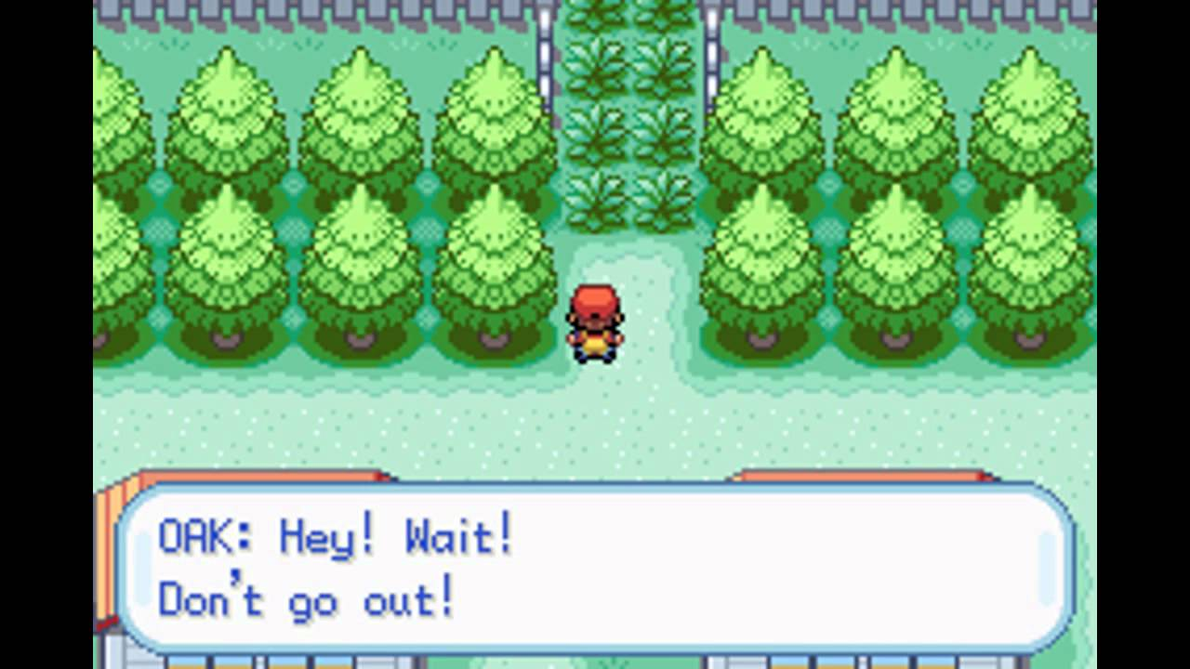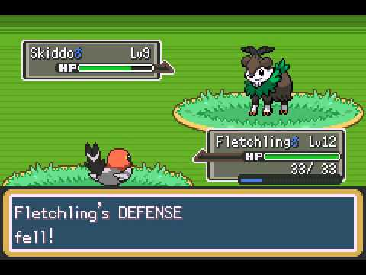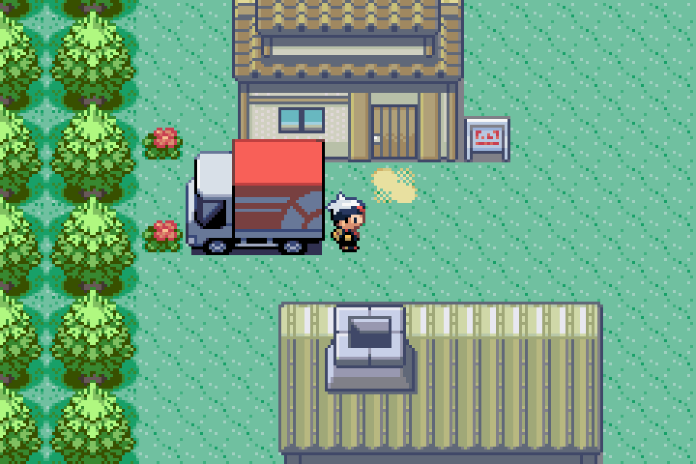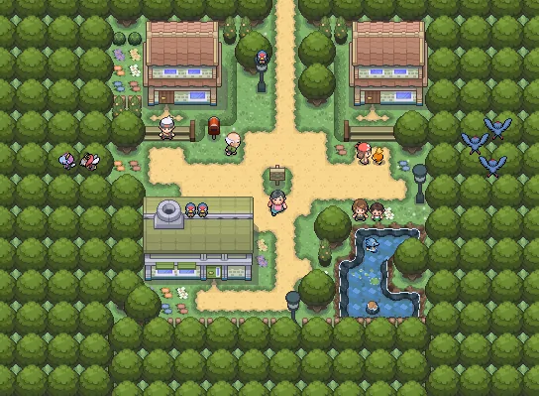**Inspiration**

**Concept Art**



**Version – 1.0 Learning Java Development**

Math

-Matrix functions (scale, translate, rotate) (use the GLM library at <https://github.com/java-graphics/glm>, paste in GLM & joou folders and delete VR related matrix functions Set uniform with Mat4.toFA_() to return float array)

-Vectors (2 -> 4)

-Interaction (vector * vector, matrix * vector)

-Random float

Graphics

-Loading texture from file (png helpful for transparency) (use source code from <https://www.youtube.com/watch?v=utU0vVE_HVo> and enable blending to get a good example)

Other

-Loading fonts from file (<https://pastebin.com/VRz0WLDp> generates a texture for the whole word and loads in a font)

**Version 0.0 – Engine Basics – Name (Classic Mini)**

Save files

-Loading in lines into list

-Writing lines from list to file

-Outputting tricky data / repetitive annoying data

-Loading info from model and photo files

Shaders

-Light positions and directions (3D lighting)

-Loading shader from file

-Creating different types of shaders

-UI shader

-Mesh colour shader (with lighting)

-Texture shader (with lighting)

Graphics

-Camera position

-Camera rotation

-Field of view

-Blurry distance

-Clipping planes

-Starting mesh by giving data and shader type

-FBX File Format?

User interface

-Buttons with changing size and colour with texture and text and transparency

-Text with colour and transparency

-Slider with changing colour, size, texture with easily accessible data

-Image with colour and transparency

-Toggle switch with colour and transparency

-Dropdown with colour and transparency

-Good aspect to keep buttons in place on all sizes and aspects

Physics

-Velocity system

-Cube colliders

-Gravity component

Audio

-Loading from file into data

-Volume

Math

-Pathfinding